|  |
| --- |
|  |
| Dimension Table Techniques |

|  |  |  |  |  |  |
| --- | --- | --- | --- | --- | --- |
| REVISION HISTORY | | | | | |
| Ver. | Description of Change | Author | Date | Approved | |
| Name | Effective Date |
| 1.0 | Initial status | Arina Marchenko | 23-NOV-2017 |  |  |

Contents

1. Geo Hierarchy 3

2. Dimension Hierarchy Analysis 4

# Geo Hierarchy

For this task I used the information from the task 1.

There are 4 tables: countries, regions, continents and worlds.

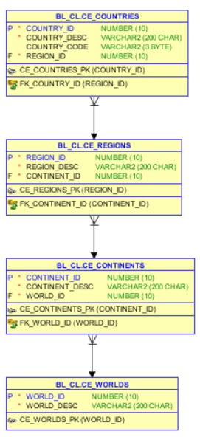

First of all I created with all this tables.

CREATE VIEW DIM_LOCATIONS AS

SELECT TO_NUMBER (NULL) AS CHILD_ID,

'WORLD' AS LEVEL_NAME,

WORLD_ID AS PARENT_ID,

WORLD_DESC AS NAME

FROM CE_WORLDS

UNION ALL

SELECT W.WORLD_ID AS CHILD_ID,

'CONTINENT' AS LEVEL_NAME,

C.CONTINENT_ID AS PARENT_ID,

CONTINENT_DESC AS NAME

FROM CE_CONTINENTS C JOIN CE_WORLDS W ON C.WORLD_ID=W.WORLD_ID

UNION ALL

SELECT C.CONTINENT_ID AS CHILD_ID,

'REGION' AS LEVEL_NAME,

R.REGION_ID AS PARENT_ID,

R.REGION_DESC AS NAME

FROM CE_REGIONS R JOIN CE_CONTINENTS C ON R.CONTINENT_ID=C.CONTINENT_ID

UNION ALL

SELECT R.REGION_ID AS CHILD_ID,

'COUNTRY' AS LEVEL_NAME,

C.COUNTRY_ID AS PARENT_ID,

C.COUNTRY_DESC AS NAME

FROM CE_COUNTRIES C JOIN CE_REGIONS R ON C.REGION_ID=R.REGION_ID;

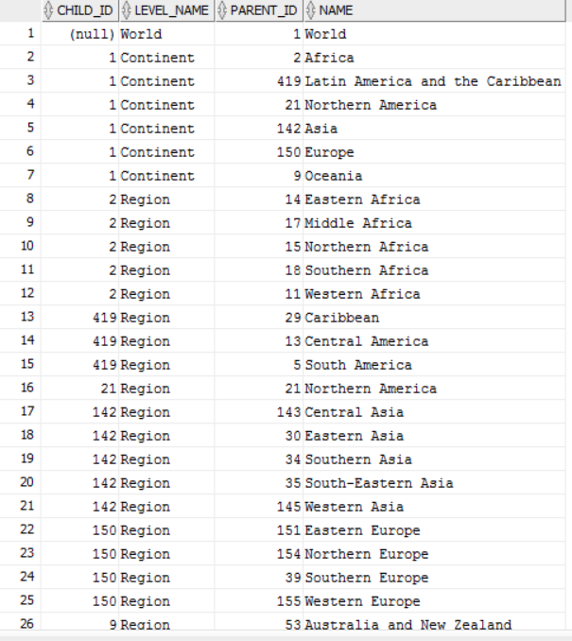

# Dimension Hierarchy Analysis

There are two options how to build the hierarchy. One of them is connect by.

We need to write start with. Then connect by prior, which means our start point of hierarchy.

From the beginning we have root, after this branch and in the end leaf.

Here is the script and screenshot that shows the process of hierarchy.

SELECT PARENT_ID, NAME,

LTRIM ( SYS_CONNECT_BY_PATH ( NAME, '==>' ), '==>' ) AS PATH,

CASE

WHEN LEVEL = 4 AND CONNECT_BY_ISLEAF = 1

THEN 'LEAF'

WHEN LEVEL = 3 AND CONNECT_BY_ISLEAF = 0

THEN 'BRANCH'

WHEN LEVEL = 2 AND CONNECT_BY_ISLEAF = 0

THEN 'BRANCH'

WHEN LEVEL = 1 AND CONNECT_BY_ISLEAF = 0

THEN 'ROOT'

END AS DEFINITION,

(SELECT COUNT(*)

FROM DIM_LOCATION DL

WHERE DIM.PARENT_ID=CHILD_ID

) AS AMOUNT_OF_CHILDREN

FROM DIM_LOCATION DIM

START WITH CHILD_ID IS NULL

CONNECT BY PRIOR PARENT_ID = CHILD_ID

ORDER SIBLINGS BY 2;

# 

Another option is with as. But in this case we decided to find the information without countries. Here is the script and screenshot that show how it works

WITH WITH_QUERY AS

(SELECT PARENT_ID, NAME,

LTRIM ( SYS_CONNECT_BY_PATH ( NAME, '==>' ), '==>' ) AS PATH,

CASE

WHEN LEVEL = 4 AND CONNECT_BY_ISLEAF = 1

THEN 'LEAF'

WHEN LEVEL = 3 AND CONNECT_BY_ISLEAF = 0

THEN 'BRANCH'

WHEN LEVEL = 2 AND CONNECT_BY_ISLEAF = 0

THEN 'BRANCH'

WHEN LEVEL = 1 AND CONNECT_BY_ISLEAF = 0

THEN 'ROOT'

END AS DEFINITION,

(SELECT COUNT(*)

FROM DIM_LOCATION DL

WHERE DL.PARENT_ID=CHILD_ID

) AS AMOUNT_OF_CHILDREN

FROM DIM_LOCATION DIM

START WITH CHILD_ID IS NULL

CONNECT BY NOCYCLE PRIOR PARENT_ID= CHILD_ID

ORDER SIBLINGS BY 2

)

SELECT * FROM WITH_QUERY WHERE AMOUNT_OF_CHILDREN!=0;

